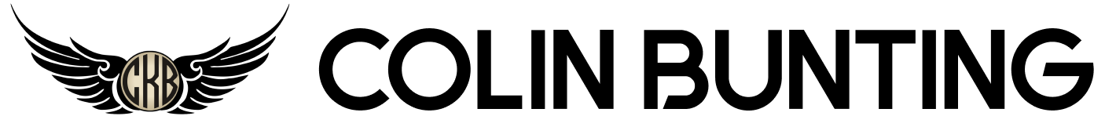
37 Barnett St, Apt 1
New Haven, CT 06515
203.606.3074
hello@colinbunting.com

Skills
I am passionate about tackling innovative, impactful products. Using the unique perspective gained from both my childhood with two metalsmith parents and my formal education in aeronautical engineering, I design elegant products that move us forward. I thrive under pressure, lead design teams to exceed project goals, and am relentlessly incorporating bleeding edge technology to improve my workflow. Let's open your next chapter and build something awe-inspiring together!

Experience

JUNE 2015 - PRESENT

Senior Research Scientist, Special Projects, Sikorsky Aircraft - Bridgeport, CT
- Designed and collaborated on multiple major classified programs with substantial budgets
- Used CATIA advanced surfacing for vehicle design, IR and RF design efforts
- Took ideas from conceptual designs into photorealistic renderings into autoclave-compatible 3D printed tools for composite fabrication, ultimately leading to flight test
- Developed and collaborated workflow to design complex conceptual models, quickly create 2D/3D/volumetric meshes, and run 2D/3D analyses at unprecedented pace
- Subject matter expert in additive manufacturing for aerospace prototyping applications: purchasing, managing, and consulting on fabrication

AUGUST 2011 - JUNE 2015

Design Engineer, Advanced Concepts, Sikorsky Aircraft - Stratford, CT
- 2 years as Configuration Design Lead where “clean sheet” aircraft OML was designed and integrated with over 20 functional designers’ hardware in major aircraft development program
- Executed design work for a wide breadth of program sizes; from small research projects all the way up large development programs
- Conceptual designs and photorealistic renderings were presented to C-level executives, Pentagon, Richard Branson, and published in trade press

2007-2011

Design Engineering Intern, Sikorsky Aircraft - Stratford, CT
- Spent 4 summers and winters developing advanced surface design and aerodynamic analysis skills when not at college
- Designed full landing gear system (aerodynamic sponson, retraction system, and rough component sizing) which was created as full-scale mock-up for customer
- Designed structural system for IR suppressor which was approved by structural SMEs and submitted as Sikorsky's government proposal

Education

2007 - 2011

Daniel Webster College, Nashua, NH - Bachelor of Science Degree in Aeronautical Engineering
ABET-Accredited, CDIO Initiative degree program emphasizing hands-on implementation in addition to standard course work. Built a high-speed recumbent bicycle for capstone project.

Skills
Extensive experience with CATIA V5, MODO, Fusion 360, OnShape, SolidWorks, Blender, HyperMesh, Stratasys Insight, PrusaSlicer, Mathcad. Also skilled with wood and metal fabrication, laser cutting, metal machining, Linux command line, Python, MacOS, Adobe Creative Suite, LabView. Strong research, sketching, conceptual, presentation, management and communication skills.

Awards
2017 Sikorsky Flight Award
2015 Sikorsky Special Recognition Award
2011 ASME Human Powered Vehicle - Men’s Speed Class - Sprint - Third Place
2011 Engineering Advisory Board - President
2010 DWC-UMASS Lowell Design-Build-Fly Team - Project Manager
2007 Sikorsky Aircraft Intern Design Competition - First Place

